2303A51830
Batch - 26
Lab assignment 11.3
Task 1: Smart Contact Manager (Arrays & Linked Lists)
Scenario
SR University’s student club requires a simple Contact Manager Application
to store members’ names and phone numbers. The system should support
efficient addition, searching, and deletion of contacts

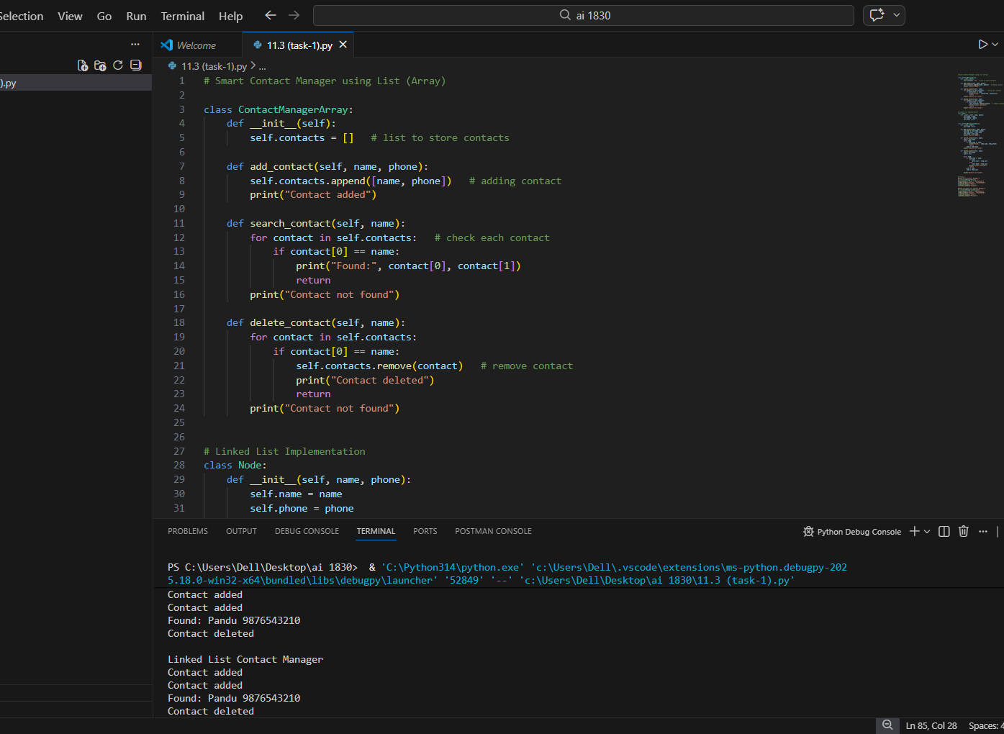
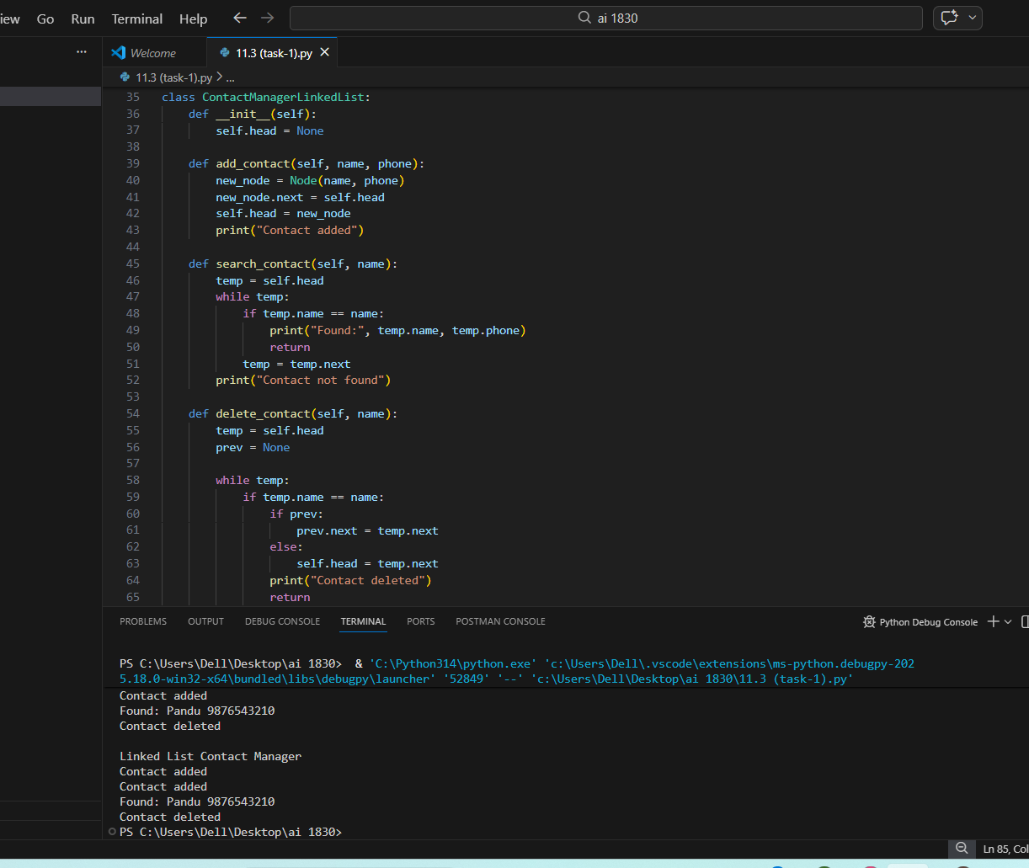
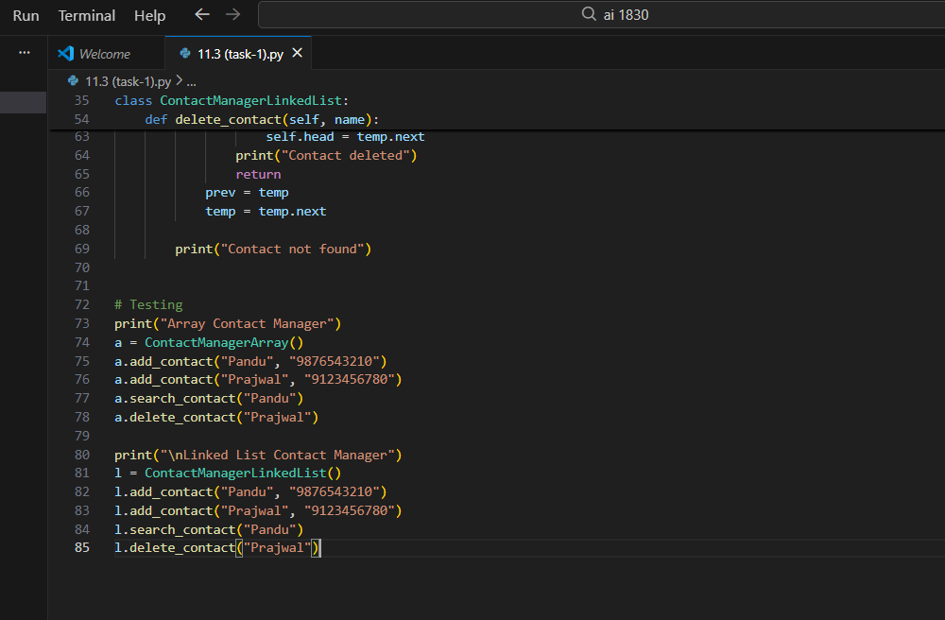
Task 2: Library Book Search System (Queues & Priority Queues)
Scenario
The SRU Library manages book borrow requests. Students and faculty submit
requests, but faculty requests must be prioritized over student requests
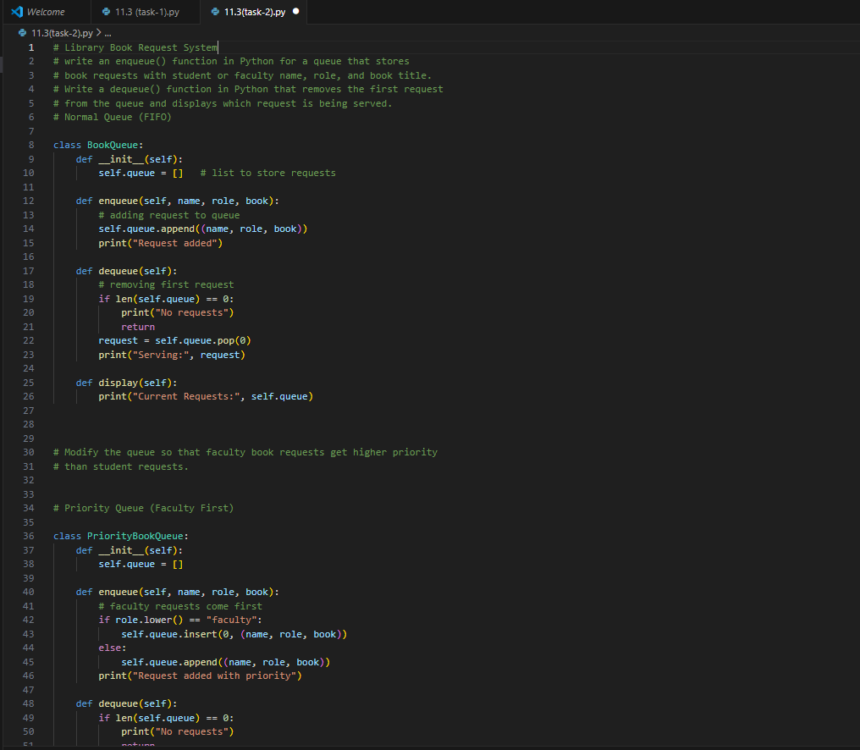
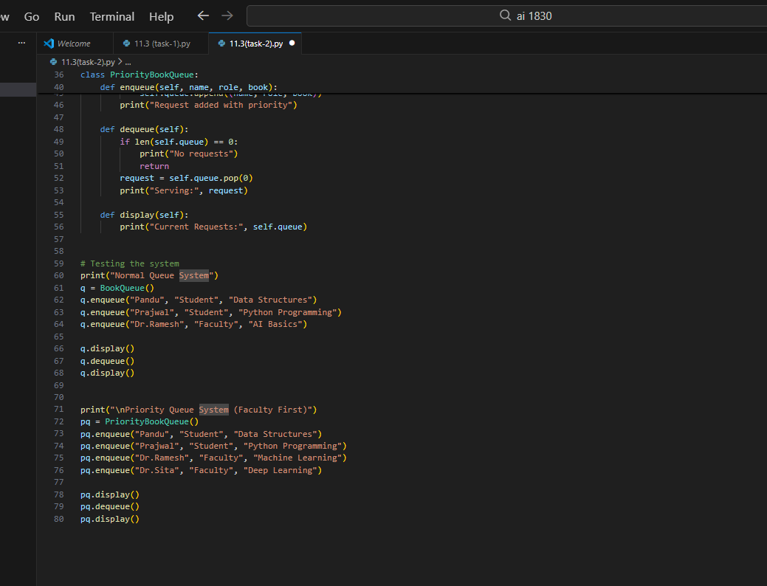
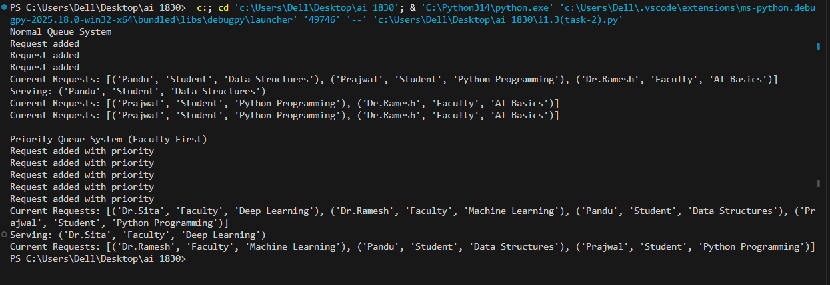

Task 3: Emergency Help Desk (Stack Implementation)
Scenario
SR University’s IT Help Desk receives technical support tickets from students
and staff. While tickets are received sequentially, issue escalation follows a
Last-In, First-Out (LIFO) approach.
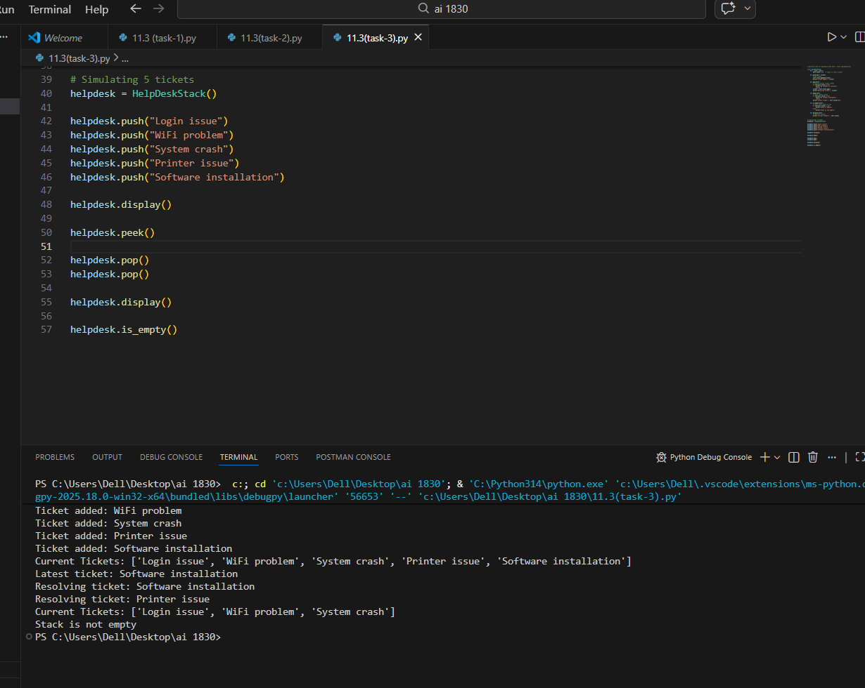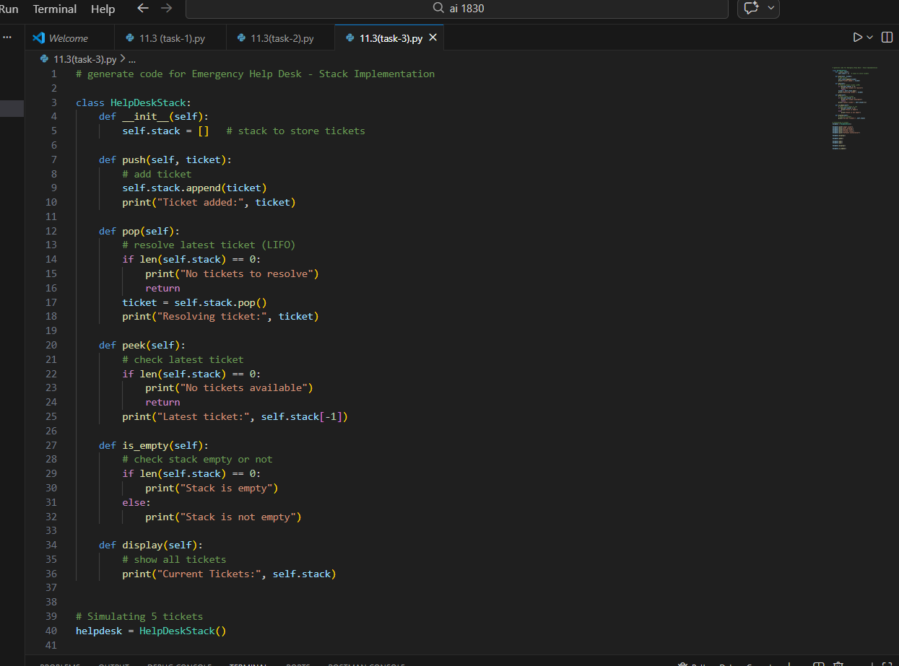

Task 4: Hash Table
Objective
To implement a Hash Table and understand collision handling

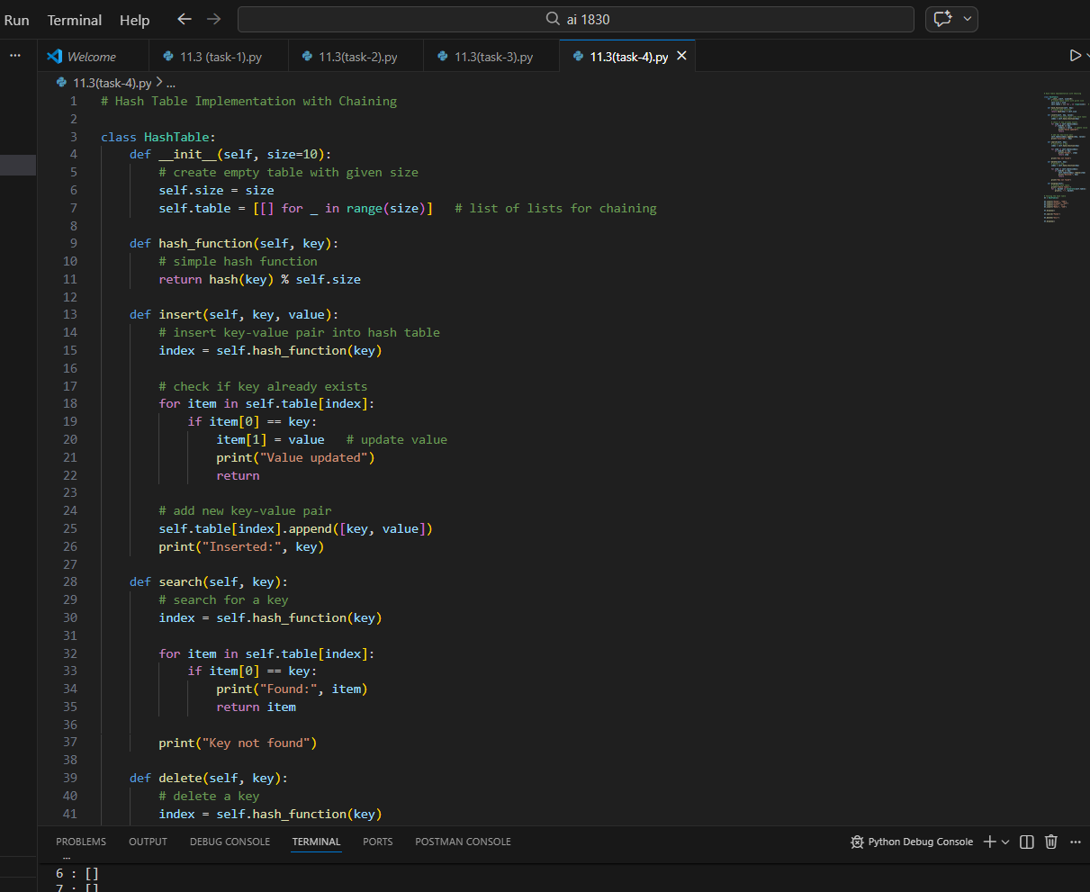
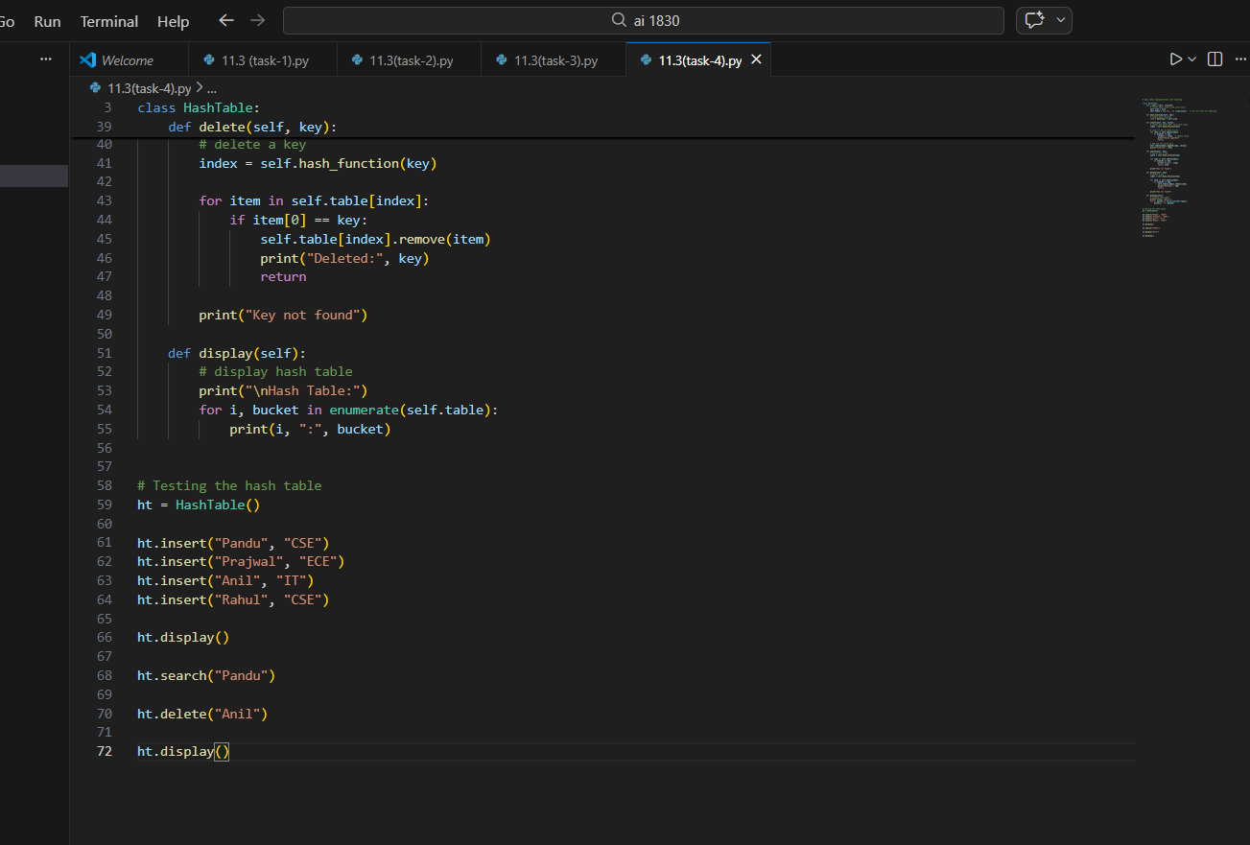
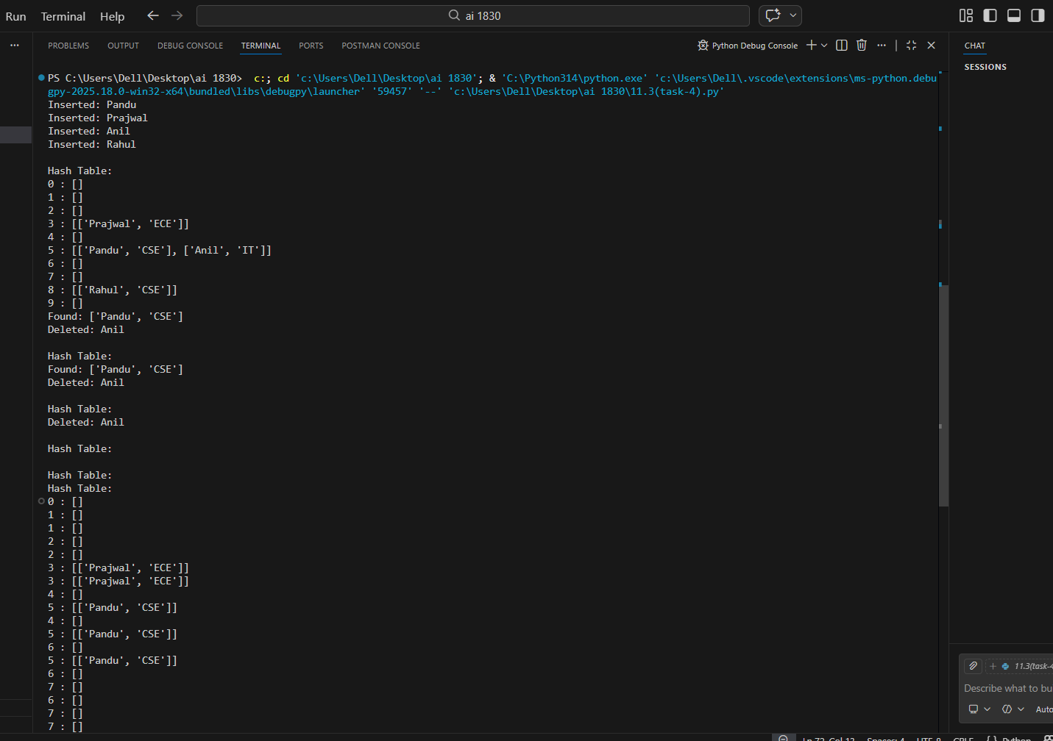

Task 5: Real-Time Application Challenge
Scenario
Design a Campus Resource Management System.

